Before completing this, first install openVPN3 from the command line.
To connect to the SkiCAMP VPN using the pop!OS interface:
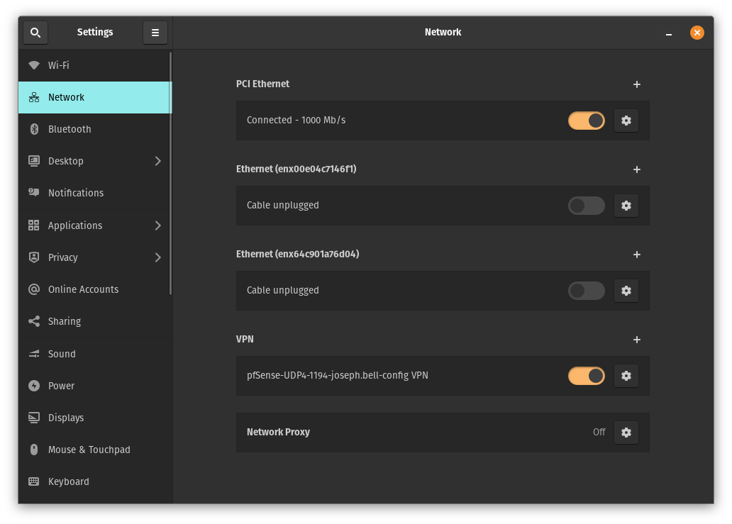
- Open settings and select Network
- Under VPN, click the plus (+) symbol

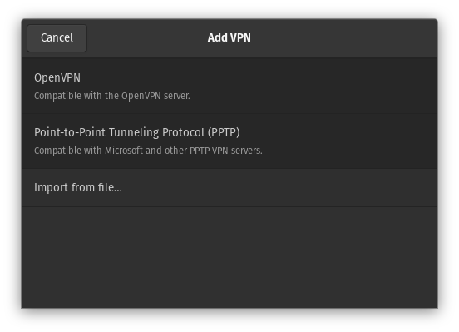
- Click `Import from file...`

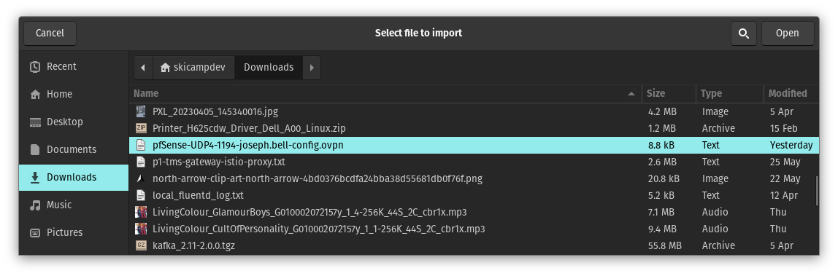
- Select the .ovpn file given by the system admin.

- Finally, On the following screen enter your username and password given to you by the sysadmin.
- Turing on the VPN should now be as easy as clicking the on/off button in the VPN settings menu.

